**Remove the header**

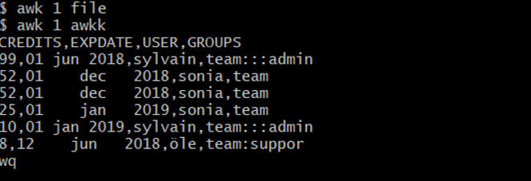

**Print lines in a range**

